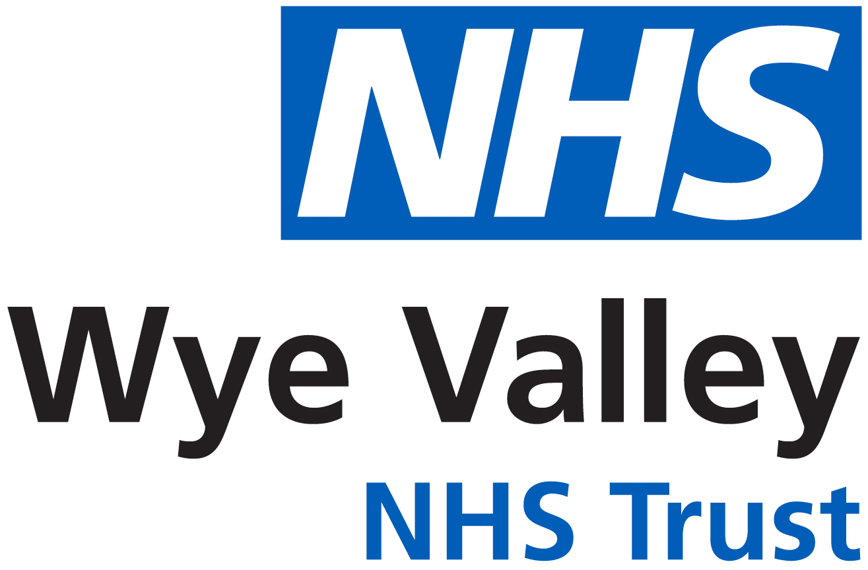

Breast Cancer Services
In Hereford

Index

Contents | Page
Herefordshire Breast Cancer Services | 3
Multi-disciplinary team | 3–4
Ward Details | 5
Useful telephone numbers | 5-6
Macmillan Cancer Information & Support Service | 5
Prescription Exemption | 6
Post-surgery bra fitting | 7
Yeleni | 7
Moving Forward Programme | 7
Herefordshire Breast Cancer Services

Internet page- https://www.wyevalley.nhs.uk/visitors-and-patients/county-hospital-(acute)/a-z-departments/breast-surgery

The breast care team at The Wye Valley Trust, County Hospital, Hereford aim to ensure that you receive the best and most caring treatment available.
The team consists of doctors, nurses and other healthcare professionals who have particular expertise in breast cancer. This “multidisciplinary” team (see details below) meet weekly at the hospital to discuss your care. This team will care for you whilst you are in hospital and following your discharge.
If there is anything, you do not understand or want to know more about, please do ask.

The Multi-disciplinary team and their contacts:
Surgical Team
Mr Kaustuv Das | Consultant Breast Reconstruction Surgeon
Mr Habib Tafazal | Consultant Breast Surgeon  Reconstruction Surgeon
Mr Claudiu Bucata | Speciality Dr Breast Surgeon
Dr Pamela Young | Physician associate breast care
Breast Care Team Secretaries
Tracey Buckley | 01432 36 4024
Leah Sprot | 01432 36 4028
Julie Paton | 01432 355 444 Ext 4370

Multi-disciplinary team continued:
Macmillan Breast Care Nurses
Jackie Jones  Lead Breast Care Nurse | 01432 36 4024  Or  01432 36 4028  wvt.bcns@nhs.net
Tracey Horne  Breast Nurse Practitioner | 01432 36 4024  Or  01432 36 4028  wvt.bcns@nhs.net
Dot Bithell | 01432 36 4024  Or  01432 36 4028  wvt.bcns@nhs.net
Kaija Assirati  Metastatic Nurse | 01432 36 4024  Or  01432 36 4028  wvt.bcns@nhs.net
Marie Edwards | 01432 36 4024  Or  01432 36 4028  wvt.bcns@nhs.net
Juliet Davies | 01432 36 4024  Or  01432 36 4028  wvt.bcns@nhs.net
Kathryn Morgan | 01432 36 4024  Or  01432 36 4028  wvt.bcns@nhs.net
Sharon Davies  Breast Navigator | 01432 355 444 Ext 5459
Prosthetic Service
Val Manuschka  Prosthetic Health Care Assistant | Tel: 01432 36 4024

Oncology Team
Dr Daniel Nelmes  (Visits Hereford Friday) | Consultant Medical Oncologist
Dr Vishal Bhalla  (Visits Hereford Friday) | Medical Oncologist
Dr Jessica Bailey  (Based in Cheltenham) | Consultant Clinical Oncologist
Ruth Bees  Becky Milliner | Consultant Radiographers
Cheltenham Secretary:  Kathy Brown  Alex McCarthy | Tel: 0300 422 3830  ghn-tr.oncology.admin2@nhs.net
Hereford Secretaries:  Oncology appointments | Tel: 01432 355 444  Ext 5751 or Ext 1819 or Ext 5777  oncology.admin@nhs.net
Clinical Schedulers  Hereford appointments | 01432 364225  mru.coordinators@nhs.net
Other members of the multi-disciplinary team include radiologists, pathologists, a psychologist, clinical trials nurses and data co-ordinators. This is not an exhaustive list. If you need support from the extended team you will be referred by your key worker/ breast care nurse.
Ward Details

Day Case Unit | 01432 355 444 Ext. 4185
Teme Ward | 01432 355 444 Ext 2257

Useful Telephone Numbers

X-ray or mammogram appointments
01432 364014 or 01432 364027

Chemotherapy helpline (24 hour service)
0300 422 3444

Radiotherapy helpline – 0300 422 3719
Macmillan Cancer Information & Support Service
The Macmillan Cancer Information & Support Centre in the Macmillan Renton Unit provides free information, support and practical advice for anyone affected by cancer. The centre is staffed by a Macmillan Information & Support Facilitator, supported by trained volunteers. We are here to help Monday to Friday from 9.30 am to 4.30 pm (although it is advisable to ring and check if staff will be available before making a special journey in).

Please feel free to drop in. You do not need an appointment. If you can’t visit the centre then contact us on:

Tel: 01432 355444 Ext 5459

E-mail: hereford.cancerinfoandsupport@nhs.net

We can offer you:

- Confidential one-to-one support

- Information on all aspects of living with cancer and treatments available

- Information on diet and nutrition

- Free internet access

- Access to relevant support & information

- Benefits Advice Session

- Advice on wigs/alternative headwear

Some of our resources are available in different languages and formats and are suitable for people with special needs.

Further details on information and support services within the local area are available in section 7 of this folder.

Prescription Exemption

If you are aged under 60 and living in England you are entitled to prescription exemption for 5 years. Please speak to your Breast Care Nurse if you have not been given an exemption form

Post Surgery bra fitting

There is no official bra fitting service in Herefordshire. We advise that after any breast surgery that you wear a fully supportive non-wired bra with high side supports for 6 weeks after surgery to reduce, discomfort, bruising and swelling. For further advice speak to your breast care nurse.

For information on bra fitting services please contact Macmillan Renton information service
01432 355444 Ext 5459

Yeleni Therapy & Support

2 Blackfriars St, Hereford HR4 9HS
Tel: 01432 342 342
E-mail: info@yelenisupport.co.uk
https://yelenisupport.co.uk/

Moving Forward Programme

When you have completed your surgery, chemotherapy and / or radiotherapy (if recommended) you can contact Breast Cancer Now to attend their ‘Moving Forward Programme’ on 0808 800 6000 or visit breastcancernow.org. Highly recommended.

Car parking at The County Hospital

Information on car parking and concessions that are available can be found in section 6 of this folder.

