

Staff uniforms at Wye Valley NHS Trust

Please find below pictures and details about staff uniforms and the role of staff members working at Wye Valley NHS Trust.

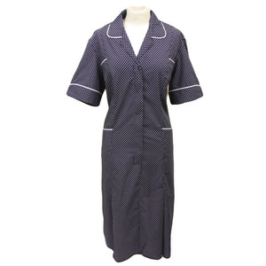 | Heads of Nursing  They wear a navy polka dot uniform. Heads of Nursing manage a number of wards, working closely with ward managers on the standards of care and the ward environment. They are responsible for cleanliness and infection control. If someone raises a concern about the quality of care they receive, it’s the Heads of Nursing who make sure that actions are taken to put things right. Matrons try to spend time with patients wherever they can to ensure we can constantly improve our performance.
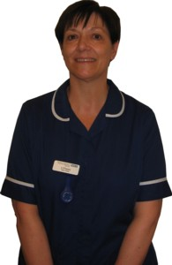 | Sister/Ward Manager  Runs the ward on a day to day basis and reports directly to the Heads of Nursing, they wear a dark blue uniform. Being the sister is a mixture of clinical care - directing activities of the team on the ward to ensuring all patients receive the clinical care required - and being a role model, demonstrating to staff what is expected professionally, and being responsible for all aspects of the ward. There is also an element of having to manage resources.
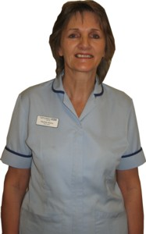 | Staff Nurses  Wear a light blue striped uniform. A nurse is a qualified healthcare professional responsible for treatment, safety, and recovery of acutely or chronically ill patients. They promote health across the ward and perform a wide range of clinical and non-clinical functions necessary to the delivery of health care. They can also be involved in medical and nursing research.
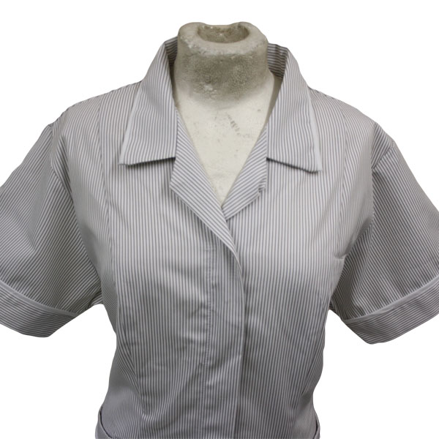 | Nursing Assistants/Health Care Assistants  Wear grey uniforms with white stripes. They work with nurses, midwives and other healthcare professionals, helping with care and looking after patients' comfort and well-being.
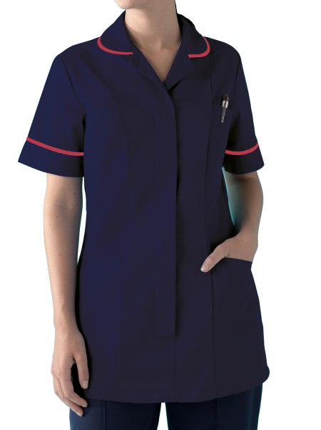 | Clinical nurse specialists  Wear a dark blue uniform with a red band on the collar and sleeves. They are registered nurses who have advanced nursing knowledge, skill and experience (which is supported by an academic post-registration qualification). The key aspects of the role include clinical care, education, research and management. They use their work with patients and other clinical staff to devise better care procedures.
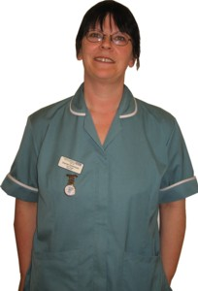 | Ward Clerks  Work under the guidance, supervision and instruction of the Ward Manager and other qualified staff on a hospital ward. They are often seen carrying out administrative duties on the ward, especially at the nurses' station.
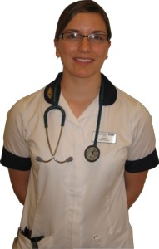 | Physiotherapists  Wear a white uniform with dark blue collars. They treat a range of physical problems caused by accidents, illness and ageing, particularly those that affect the muscles, bones, heart, circulation and lungs. Physiotherapists work across the Trust assessing, treating and advising on respiratory, neurological and musculoskeletal conditions, to enable patients to be discharged.
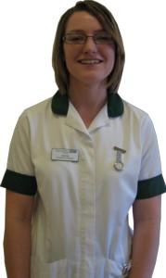 | Occupational therapists  Wear white uniforms with green collars. They help people to overcome physical, psychological or social problems arising from illness or disability, by concentrating on what they are able to achieve, rather than on their disabilities. Occupational Therapy enables people to achieve as much function/independence as possible. Therapists try to foresee any problems people may experience, ensuring a safe discharge from hospital.
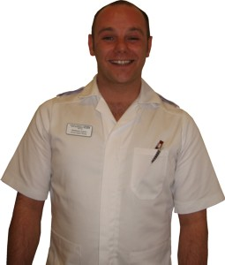 | Male ward staff  They are becoming more and more common thanks to the favourable working conditions in the NHS and retraining programmes. Our male staff wear white uniforms, their job role is indicated by the different coloured epaulettes on their shoulders.
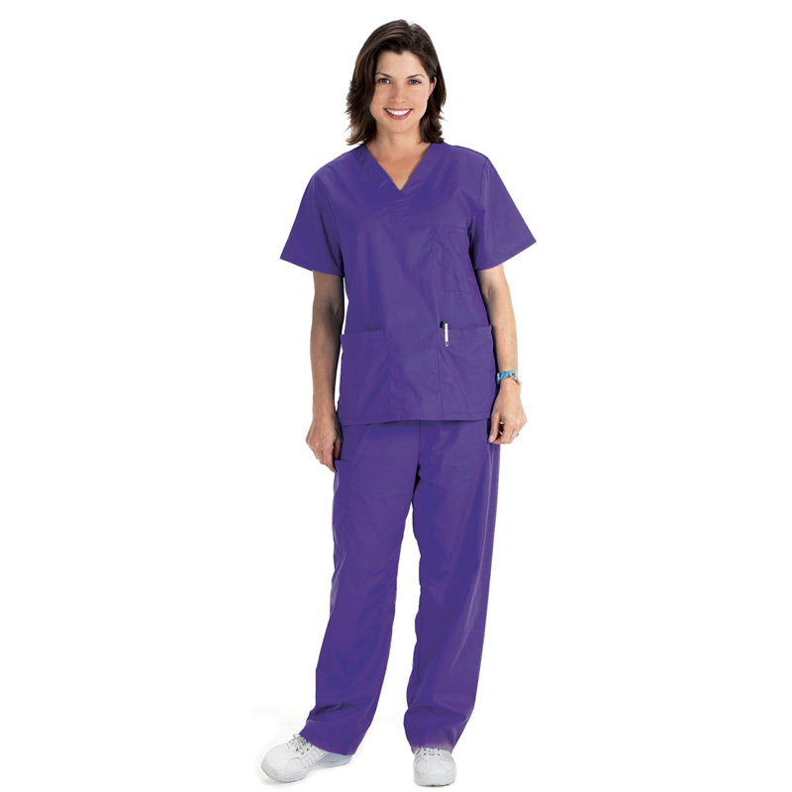 | Housekeepers  Wear purple scrubs and are responsible for keeping the ward clean, tidy and fully stocked.

